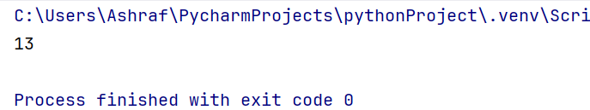
ALL OUTPUTS ARE IN SEQUENCE

